1. **Declare a div() function with two parameters. Then call the function and pass two numbers and display their division.**

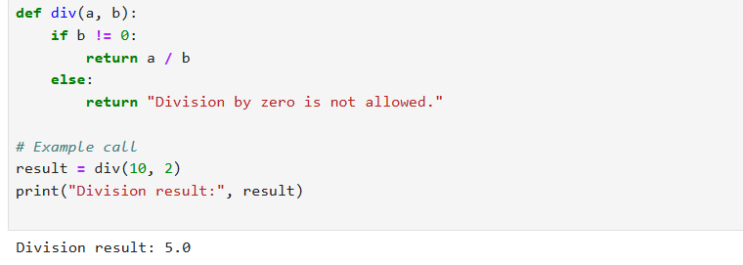

1. **Declare a square() function with one parameter.Then call the function and pass one number and display the square of that number .**

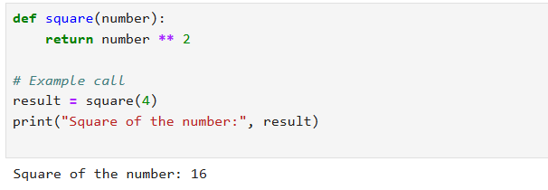

1. **Using max() and min() functions display the maximum and minimum of 5 random numbers.**

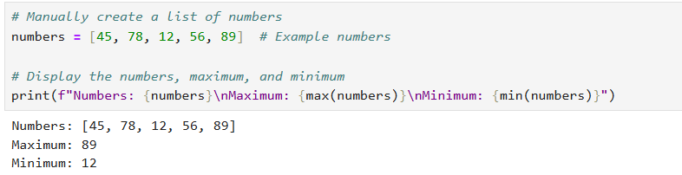

1. **Accept a name from the user and display that in lower case using lower() function**

